Microsoft Azure Storage Explorer Documentation

Goal
The goal of this setup is to install Microsoft Azure Storage Explorer, sign in, and access stored files from Azure Storage accounts.
Steps to Use Azure Storage Explorer
Step 1: Download and Install Storage Explorer
- Go to the official Microsoft website: https://azure.microsoft.com/en-us/features/storage-explorer/
- Download the version suitable for your operating system.
- Install the application on your computer.
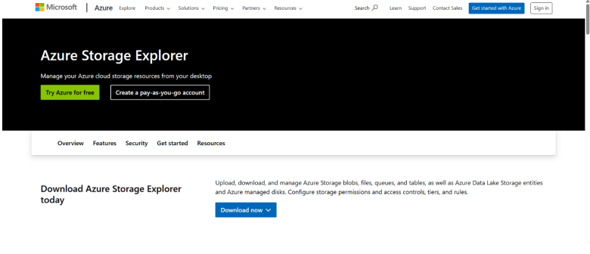
Step 2: Open Storage Explorer
- Launch Microsoft Azure Storage Explorer after installation.
- The home page will be displayed.
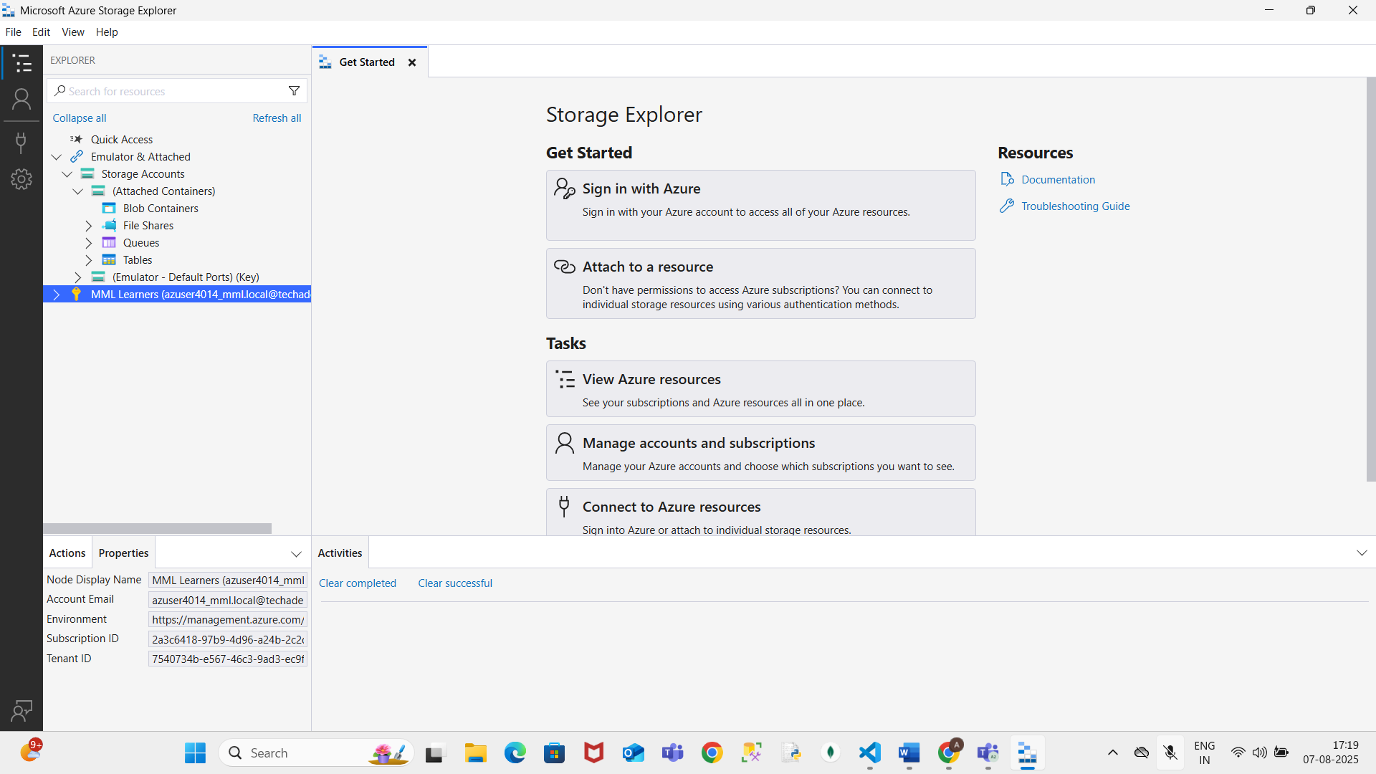
Step 3: Sign In to Azure Account
- Click Sign in at the top left.
- Use your Azure account credentials to sign in.
Step 4: Access Storage Account
- In the left panel, expand Storage Accounts.
- Select the storage account you want to view.
Step 5: Navigate to Blob Container
- Under the selected storage account, expand Blob Containers.
- Click on the desired blob container.
- You will see the list of files stored in that container.
Step 6: View Stored File
- Click the file name to open and view it.
- The file content will be displayed in Storage Explorer.
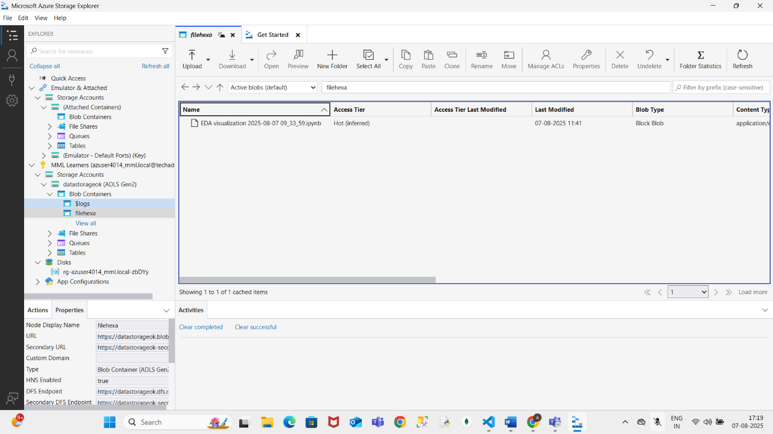

Conclusion

You have successfully installed Microsoft Azure Storage Explorer, signed in to your Azure account, and accessed files stored in a blob container.

